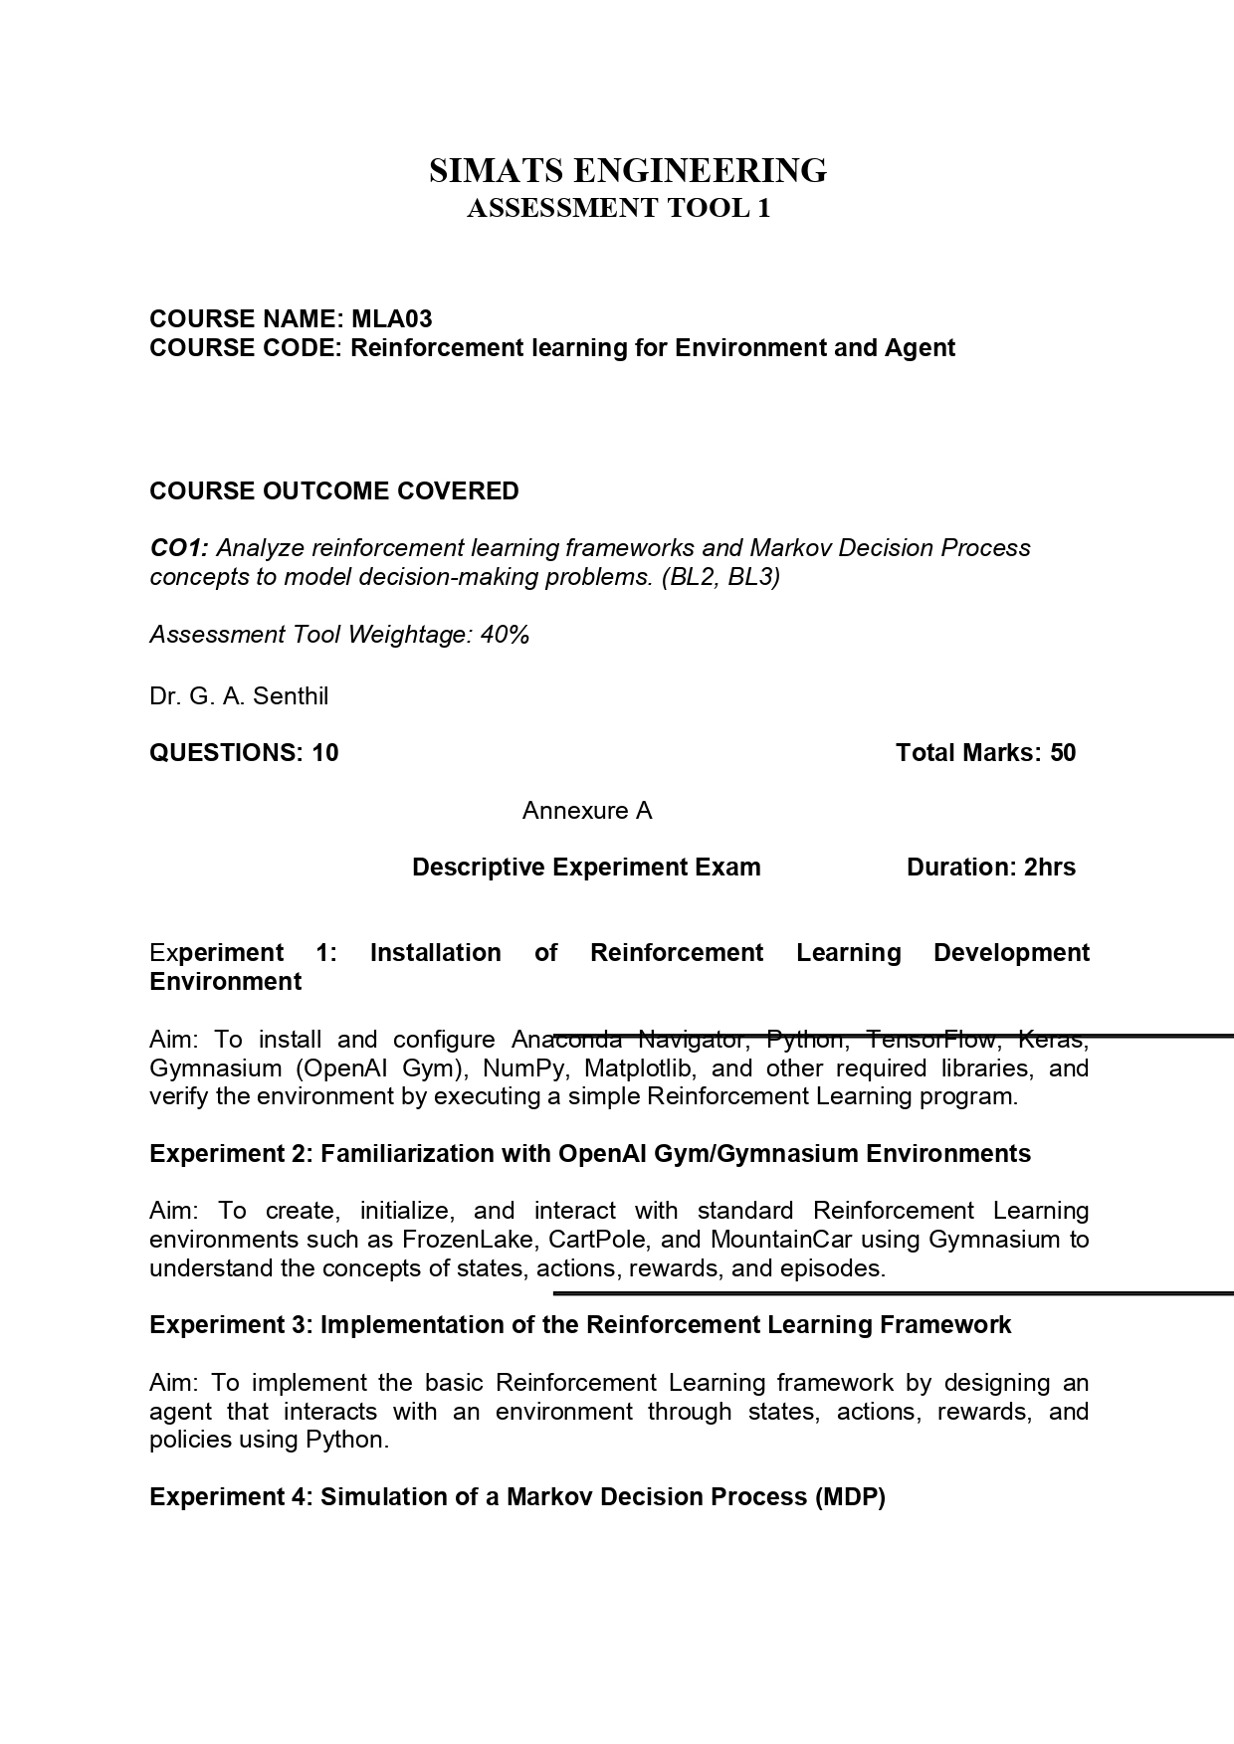

MLA0301-Reinforement Learning

CO1_AT1

Descriptive Experiment Examination

K. V. S. S. Jeswanth Babu 192472012

Experiment 1: Installation of Reinforcement Learning Development Environment
Aim
To install and configure Anaconda Navigator, Python, TensorFlow, Keras, Gymnasium (OpenAI Gym), NumPy, Matplotlib, and other required libraries, and verify the environment by executing a simple Reinforcement Learning program.

Algorithm
- Install Anaconda Navigator.
- Create a new Python environment.
- Install the required libraries:
  - NumPy
  - Matplotlib
  - Gymnasium
  - TensorFlow
  - Keras
- Import the installed libraries.
- Create a FrozenLake environment.
- Reset the environment.
- Display the initial state.
- Verify that the environment is working correctly.

Python Program
import gymnasium as gym
# Create FrozenLake environment env = gym.make("FrozenLake-v1") # Reset environment

state, info = env.reset() print("Environment created successfully!") print("Initial State:", state)
env.close()

Input
No user input is required.

Output

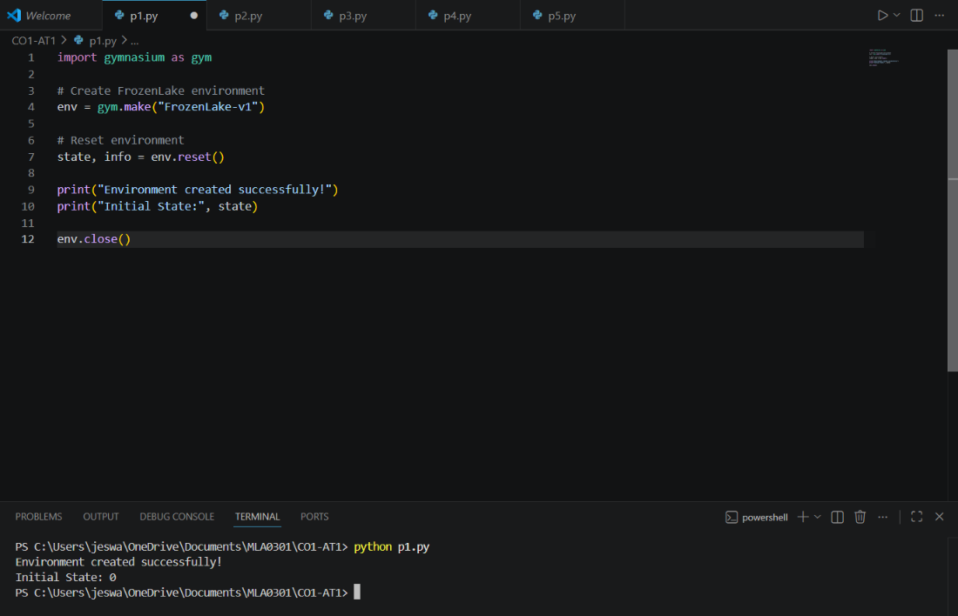

Result
The Reinforcement Learning development environment was successfully installed and verified by creating and initializing the FrozenLake environment.

Experiment 2: Familiarization with OpenAI Gym/Gymnasium Environments
Aim
To create, initialize, and interact with standard Reinforcement Learning environments such as FrozenLake using Gymnasium to understand the concepts of states, actions, rewards, and episodes.

Algorithm
- Import the Gymnasium library.
- Create the FrozenLake environment.
- Reset the environment to obtain the initial state.
- Select a random action.
- Execute the action using the step() function.
- Observe the next state, reward, and termination status.
- Display the obtained results.
- Close the environment.

Python Program
import gymnasium as gym
# Create FrozenLake environment env = gym.make("FrozenLake-v1") # Reset environment
state, info = env.reset() print("Initial State:", state) # Take a random action
action = env.action_space.sample()
next_state, reward, terminated, truncated, info = env.step(action)

print("Action Taken:", action) print("Next State:", next_state) print("Reward:", reward)
print("Episode Finished:", terminated or truncated) env.close()

Input
No user input is required.

Output

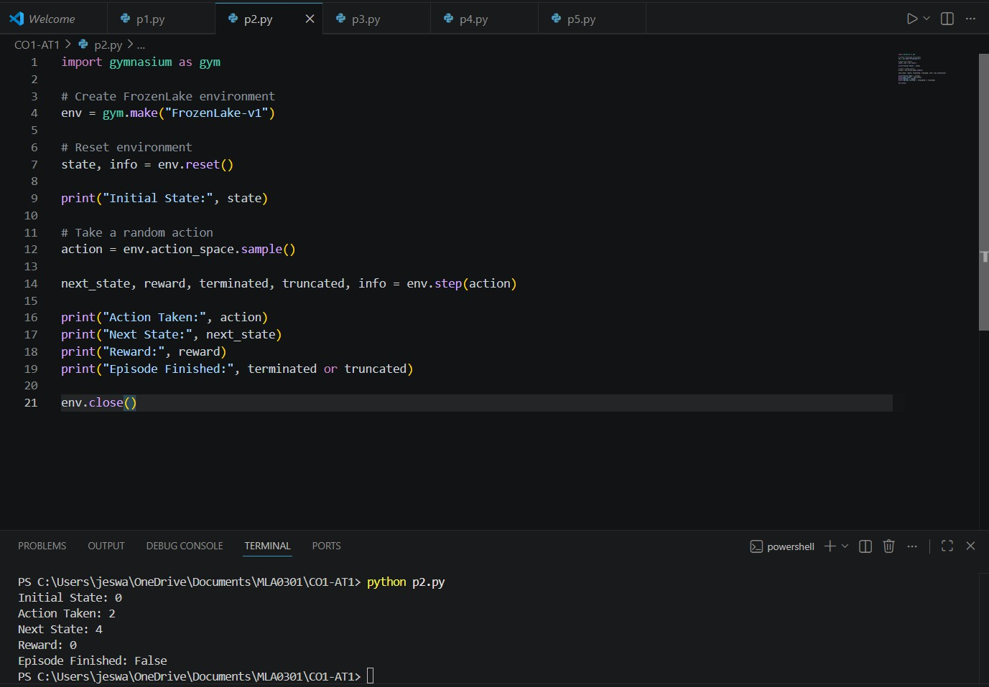

Result
The Gymnasium FrozenLake environment was successfully created, and the agent interacted with the environment by performing a random action.

Experiment 3: Implementation of the Reinforcement Learning Framework Aim
To implement the basic Reinforcement Learning framework by designing an agent that interacts with an environment through states, actions, rewards, and policies using Python.

Algorithm
- Create the FrozenLake environment.
- Reset the environment.
- Repeat for five steps:
  - Select a random action.
  - Execute the action.
  - Receive the next state and reward.
  - Display the interaction details.
- Stop if the episode ends.

Python Program
import gymnasium as gym
env = gym.make("FrozenLake-v1") state, info = env.reset() print("Starting State:", state)
for i in range(5):
action = env.action_space.sample()
next_state, reward, terminated, truncated, info = env.step(action) print("Step:", i + 1)
print("Action:", action)

print("State:", next_state) print("Reward:", reward) state = next_state
if terminated or truncated: break
env.close()

Input
No user input is required.

Output
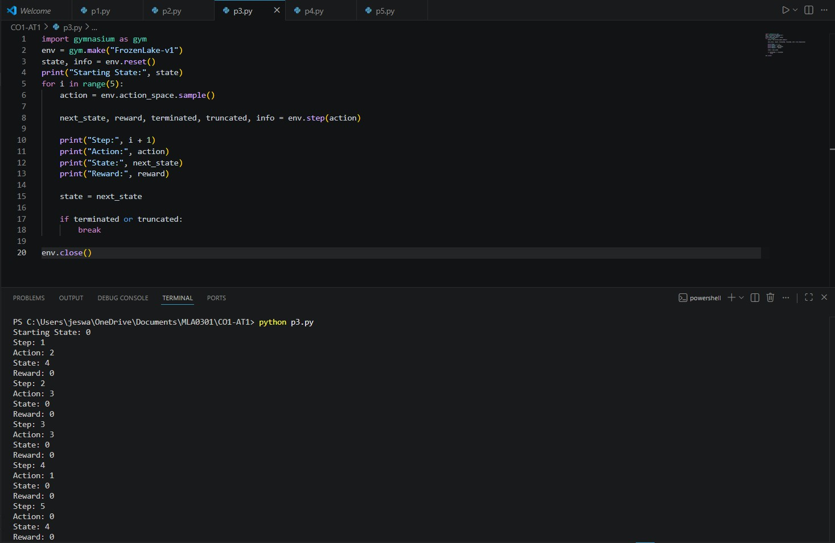

Result
The Reinforcement Learning framework was successfully implemented, demonstrating the interaction between the agent and the environment through states, actions, and rewards.

Experiment 4: Simulation of a Markov Decision Process (MDP) Aim
To develop a simple Markov Decision Process model and simulate state transitions, reward functions, and policy execution for understanding sequential decision-making problems.

Algorithm
- Define states and actions.
- Define state transition probabilities.
- Define rewards.
- Choose an action.
- Display the next state and reward.
- Repeat for all states.

Python Program states = ["A", "B", "C"] transitions = {
"A": ("B", 5),
"B": ("C", 10),
"C": ("A", 2)
}
current_state = "A" for i in range(3):
next_state, reward = transitions[current_state] print("Current State:", current_state) print("Next State:", next_state) print("Reward:", reward)

print()
current_state = next_state

Input
No user input is required.

Output

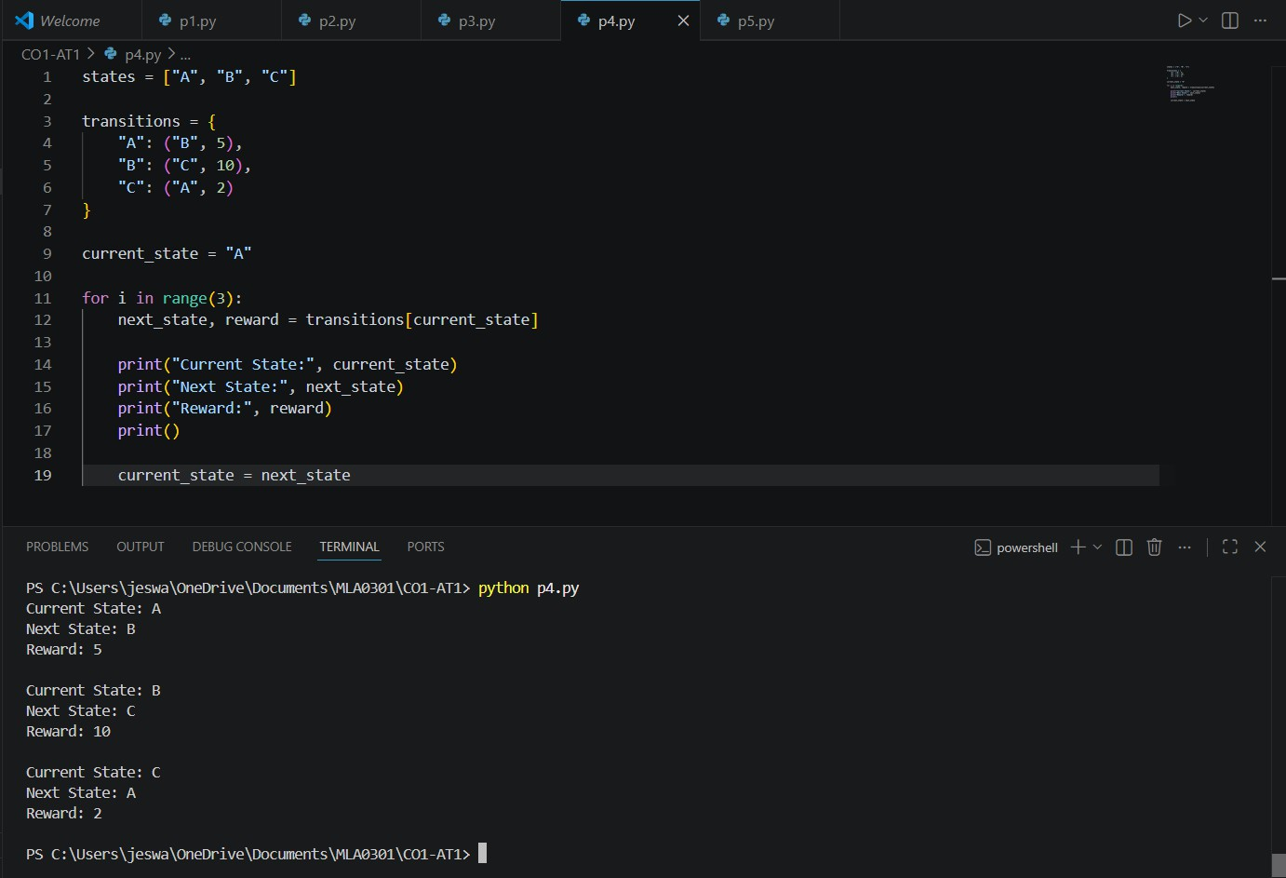

Result
A simple Markov Decision Process was successfully simulated using state transitions and reward functions.

Experiment 5: Bellman Equation Demonstration Aim
To implement Bellman Expectation and Bellman Optimality Equations for calculating state-value functions and analyze the convergence of value estimation.

Algorithm
- Define rewards for each state.
- Initialize state values to zero.
- Apply the Bellman equation iteratively.
- Update the value of each state.
- Display the updated state values.

Python Program
gamma = 0.9
rewards = [5, 10, 15]
values = [0, 0, 0]
for i in range(len(rewards)):
values[i] = rewards[i] + gamma * values[i] print("Updated State Values")
for i in range(len(values)): print("State", i, ":", values[i])

Input
No user input is required.

Output

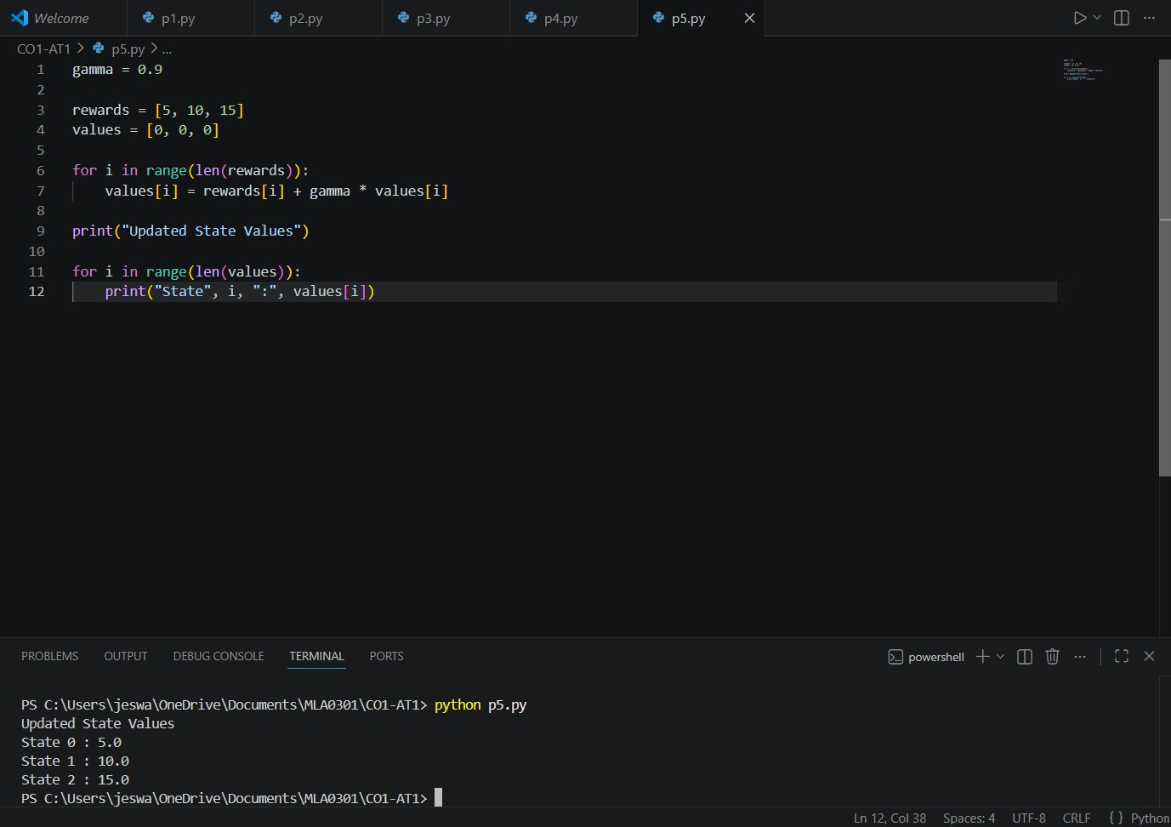

Result
The Bellman Equation was successfully implemented to estimate the value of each state.

